
Dr. Ahmed Wasif Reza
Associate Professor
Department of Computer Science
&Engineering

CSE 103: Structured Programming
Fall 2021
East West University
Department of Computer Science and Engineering
Project

Date: 9 January, 2022
Digital Phone Book 

 Taslima Akter Sathi : 2021-1-60-114
 Sagor Ahmed : 2021-3-60-117
 Ifrat Jahan Oishi : 2021-3-60-229

CSE103 – Structured Programming

Project Evaluation Rubrics

 |  | Max. |  | Awarded
A. Report
i. | Introduction / Problem statement
iv. | System Design
v. | Program output (Screen shots)
vi. | Source code
vii. Disk/CD neatly attached (Y/N)
B. Source Code
i. | Style
 | Indentation
 | Self-documentation
ii. | Modularity (small size functions)
iii. | Error reporting capabilities
iv. | Code efficiency, strategy, and originality
C. Program Execution
i. | Compile without errors
ii. | User friendly
iii. | Error free during runtime
iv. | Program output
D. Presentation and Demonstration [Psychomotor Domain]
i. Presentation and communication skills (Soft skill)
E. Bonus
i. | Extra significant features
 | TOTAL |  | 11

CSE103 – Structured Programming
Project Declaration
(Student 1)

Student ID: 2021-1-60-114

Name: Taslima Akter Sathi

Session: 1

Project No: 5

Date submitted: 9 January, 2022

Deadline of the project: 9 January, 2022

My contribution in this project: 33.33%

Description of my contribution in this project: Although we work as team, I personally worked phonebook contact list, block list & searched option.
Number of hours I spent in doing this project: 7 days.

(Student 2)

Student ID: 2021-3-60-117

Name: Sagor Ahmed

Session: 3

Project No: 5

Date submitted: 9 January, 2022

Deadline of the project: 9 January, 2022

My contribution in this project: 33.33%

Description of my contribution in this project: Although we work as team, I personally work with design of the Phonebook, block and unblocking of phonebook.

Number of hours I spent in doing this project: 7 days.

(Student 3)

Student ID: 2021-3-60-229

Name: Ifrat Jahan Oishi

Session: 3

Project No: 5

Date submitted: 9 January, 2022

Deadline of the project: 9 January, 2022

My contribution in this project: 33.33%

Description of my contribution in this project: Although we work as team, I personally worked on contact edit, remove & exit option.

Number of hours I spent in doing this project: 7 days.

We hereby certify that this project is done by us. We did not copying from any other resources. We declare that no part of our work has been copied from or by other groups, but we take ideas from other groups.

Signature of the students who created this project:

- Signature: Taslima Sathi Date: 9 January, 2022

- Signature: Sagor Ahmed Date: 9 January, 2022

- Signature: Ifrat oishi Date: 9 January, 2022

INTRODUCTION OF PHONEBOOK

- This project is created by C programming. Basically this application is about phonebook. There are so many features in this application. Add contact, edit contact, search, delete, block contact and also unblock contact.

- Here we can add new contact and editing them or deleting them. The main feature is block & unblocking contacts. Here we can easily block any contact and also can unblock them later.

- Every personal information phone number, name, email, address and department will be asked while adding a contact into the Phone book and the record can be modified later.

- Every single information needed to be valid. Otherwise the program will not take the information you gave. So you have to input the valid information again.

- This application is build by some functions and every functions are so easy to understand.

- We are still working on our project. People who are using our application will get an update of this phonebook application. Then everyone will experience the new features.

SYSTEM DESING
start

Welcome
Start
Start

Stop
If you want to
continue
Menu
Exit
Unblock contact
Block contact
Edit contact
Search contact
Add contacts

View block contact
Remove
contact

View all contact

If True If False

PROGRAM OUTPUT

- Main menu:
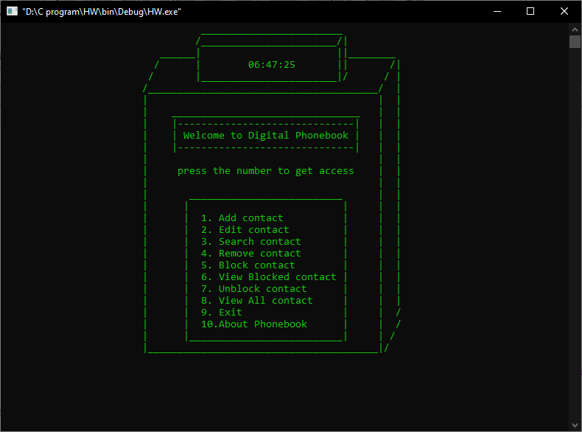

- Add contact:
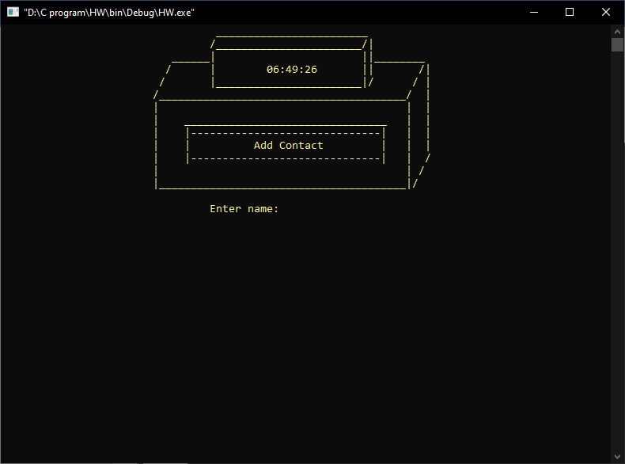
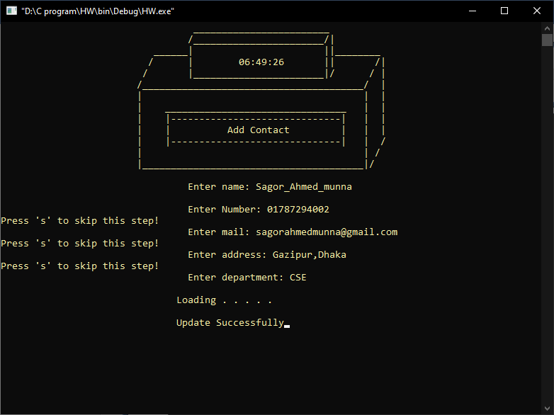

- Edit contact:
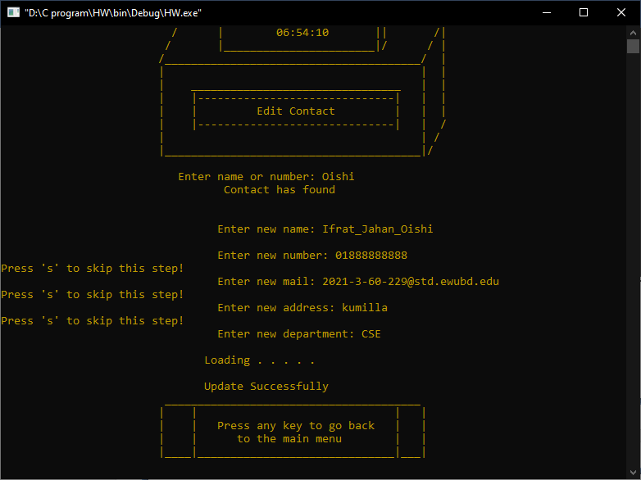

- Search contact:
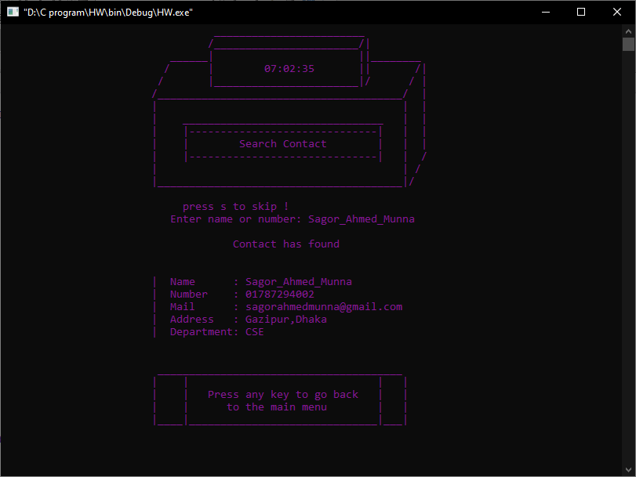
- Remove contact:

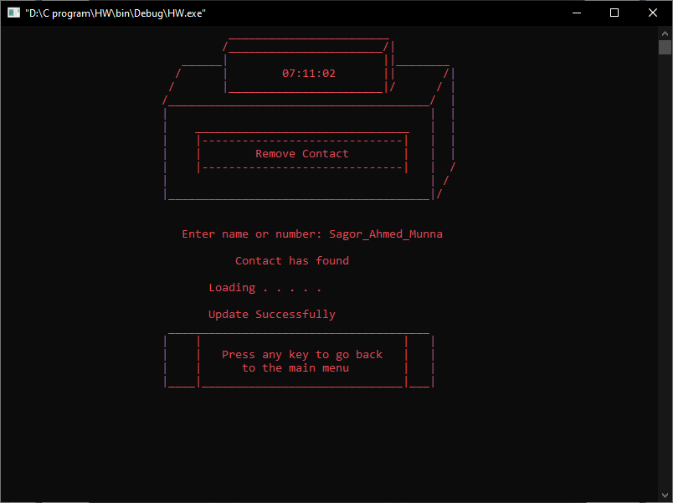

- Block contact:
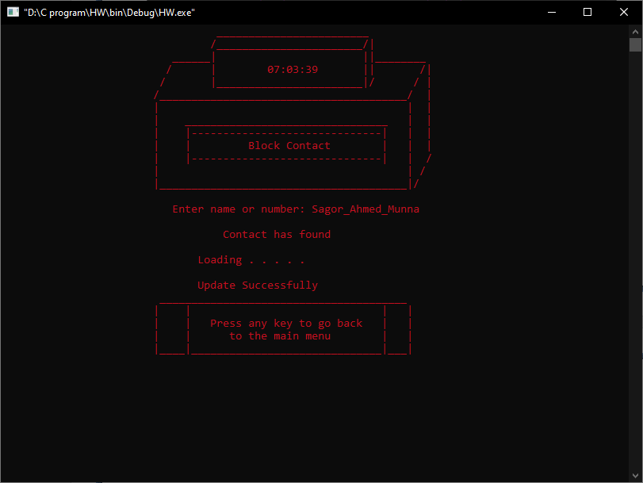
- View Blocked contact:
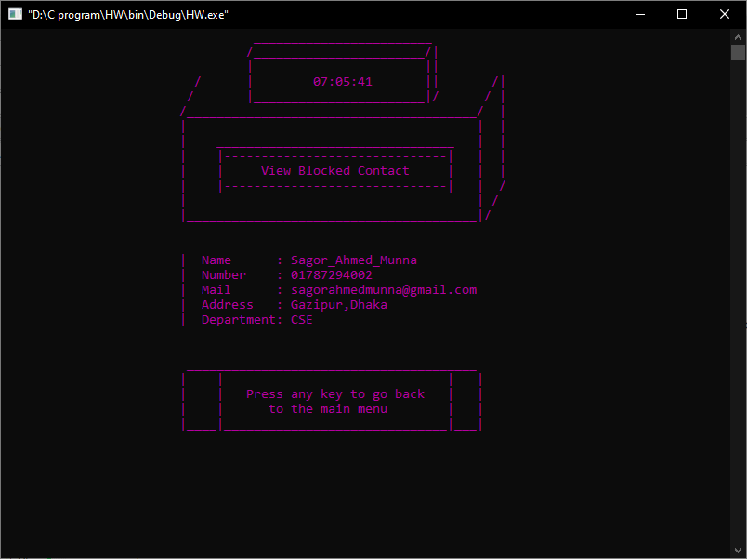

- Unblock contact:
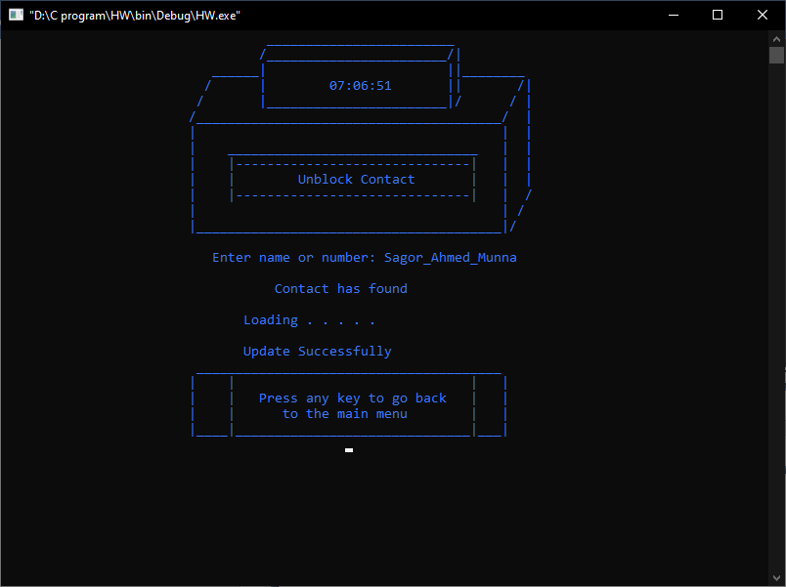

- All contact:
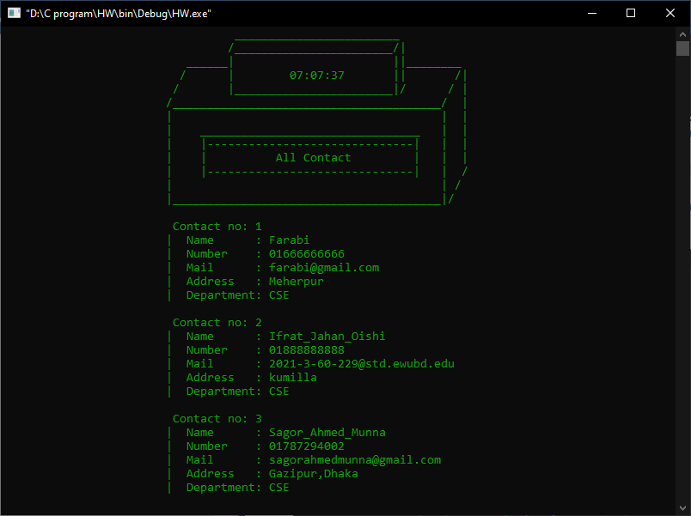
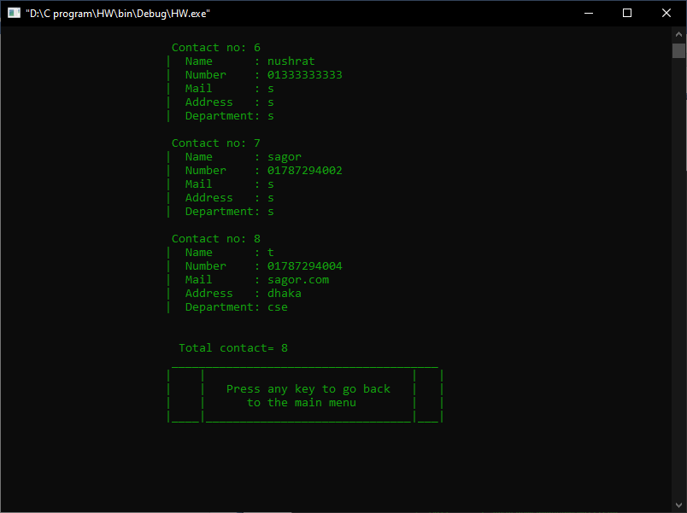

Exit:

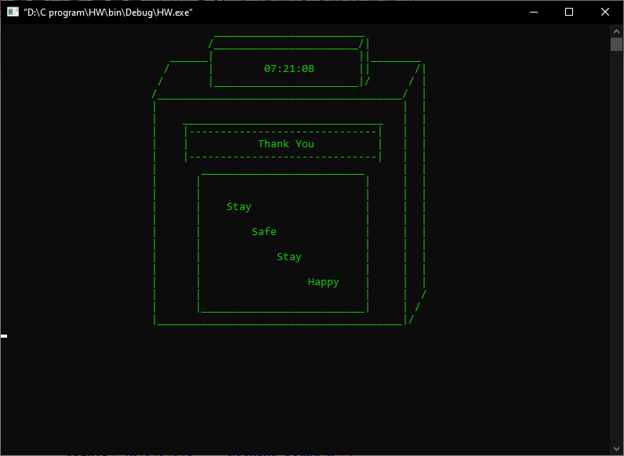
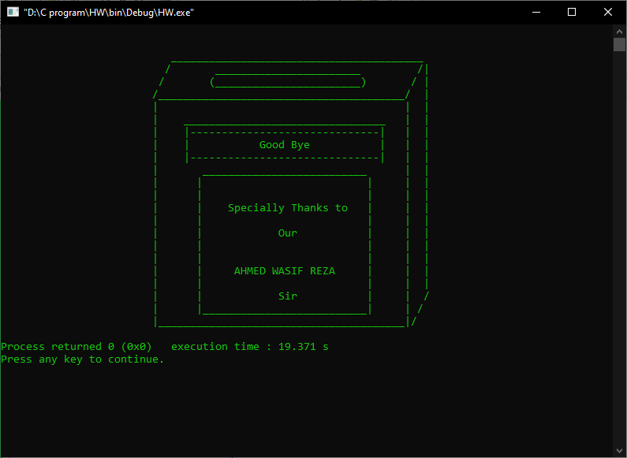

About Phone Book:
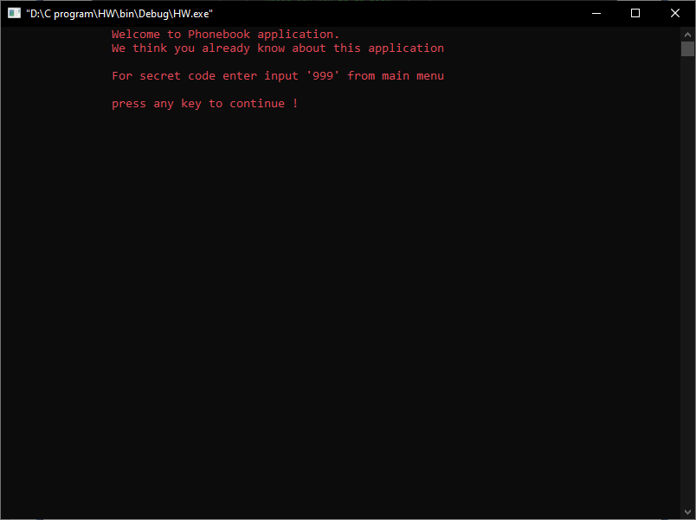

Secret Code:
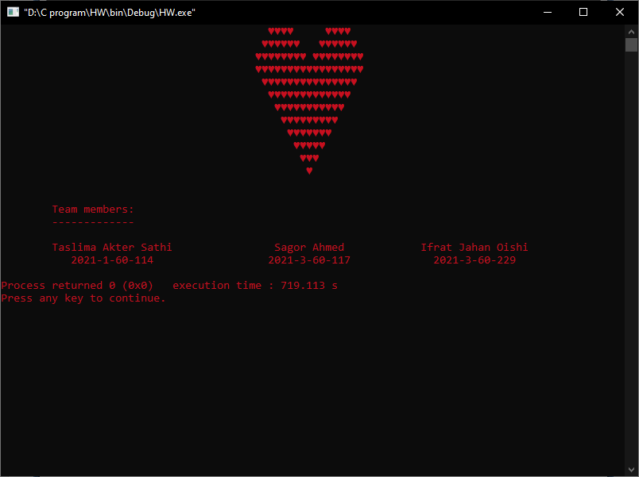

LIMITATION

There are some limitation in this project.

- It is not possible to attach any kind of picture or media.

SOURCE CODE

#include <stdio.h>
#include <string.h>
#include <stdlib.h>
#include <time.h>
#include <conio.h>
#include <windows.h>
void Option();
void HoldMenu();
void Option();
void Secret(){
system("cls");
system("color 04");
int i,j, rows=9;
printf("\t\t\t\t\t");
for(i = rows/2; i <= rows; i+=2){
for(j = 1; j < rows-i; j+=2){
printf(" ");
}
for(j = 1; j <= i; j++){
printf("%c",3);
}
for(j = 1; j <= rows-i; j++){
printf(" ");
}
for(j = 1; j <= i; j++){
printf("%c",3);
}
printf("\n\t\t\t\t\t");Sleep(50);
}
for(i = rows; i >= 1; i--){
if(i!=rows)
printf("\t\t\t\t\t");
for(j = i; j < rows; j++){
printf(" ");
}
for(j = 1; j <= (i*2)-1; j++){
printf("%c",3);
}
printf("\n");Sleep(50);
}
printf("\n\n\tTeam members:");Sleep(50);
printf("\n\t-------------");Sleep(50);
printf("\n\n\tTaslima Akter Sathi\t\t Sagor Ahmed \t\t Ifrat Jahan Oishi\n");Sleep(50);
printf("\t 2021-1-60-114 \t\t 2021-3-60-117\t\t 2021-3-60-229\n");
}
void About(){
system("cls");
printf("\t\tWelcome to Phonebook application.\n"
"\t\tWe think you already know about this application\n"
"\n\t\tFor secret code enter input '999' from main menu\n");
printf("\n\t\tpress any key to continue !\n");
getch();
HoldMenu();Option();
}
void EditContact(){
system("cls");
system("color 06");
menuUpper();
printf("\t\t\t| | Edit Contact | | |\n");Sleep(35);
menuLower();
printf("\t\t\t ");
printf("\n");
char target[50];
int flag=0;
printf("\t\t\t Enter name or number: ");
scanf("%s",target);
while(1){
if((target[0]=='0'&&target[1]=='1')&&(target[2]=='3'||target[2]=='5'||target[2]=='6'||target[2]=='7'||target[2]=='8'||target[2]=='9')
&&(strlen(target)==11)){
FILE *fp,*fp1;
fp=fopen("phonebook.txt","r");
fp1=fopen("temp.txt","w");
char name[50];
char num[20];
char mail[50];
char address[50];
char department[20];
while(fscanf(fp,"%s %s %s %s %s",name,num,mail,address,department)!=EOF){
if(strcmp(target,num)==0){
PlaySound(TEXT("contact_found.wav"),NULL,SND_ASYNC);
printf("\t\t Contact has found\n");
printf("\n\n\t\t Enter new name: ");
scanf("%s",name);
while(1){
int CountName=0;
for(int i=0;(name[i]>='A'&&name[i]<='Z')||(name[i]>='a'&&name[i]<='z')||name[i]=='_';i++){
CountName++;
}
if(CountName==strlen(name))
break;
else{
PlaySound(TEXT("error.wav"),NULL,SND_ASYNC);
printf("\t\t\t Invalid name\n\n\t\t\t Enter again: ");
scanf("%s",name);
}
}
printf("\n\t\t Enter new number: ");
scanf("%s",num);
while(1){
if((num[0]=='0'&&num[1]=='1')&&(num[2]=='3'||num[2]=='5'||num[2]=='6'||num[2]=='7'||num[2]=='8'||num[2]=='9')
&&(strlen(num)==11))
break;
else{
PlaySound(TEXT("error.wav"),NULL,SND_ASYNC);
printf("\t\t\t Invalid number\n\n\t\t\t Enter again: ");
scanf("%s",num);
}
}
printf("Press 's' to skip this step!");
printf("\n\t\t ");
printf("Enter new mail: ");
scanf("%s",mail);
if(strlen(mail)==1&&(mail[0]=='S'||mail[0]=='s'))
printf("Skipped this step!\n");
else{
while(1){
int CountMail=0;
for(int i=0;(mail[i]>='a'&&mail[i]<='z')||(mail[i]>='0'&&mail[i]<='9')||mail[i]=='@'||mail[i]=='.'||mail[i]=='-'||mail[i]=='_';i++){
CountMail++;
}
int L=strlen(mail);
if((CountMail==L)&&(mail[L-4]=='.')&&((mail[L-3]=='c'&&mail[L-2]=='o'&&mail[L-1]=='m')||(mail[L-3]=='e'&&mail[L-2]=='d'&&mail[L-1]=='u')))
break;
else{
PlaySound(TEXT("error.wav"),NULL,SND_ASYNC);
printf("\t\t\t Invalid Mail\n\n\t\t\t Enter again: ");
scanf("%s",mail);
}
}
}
printf("Press 's' to skip this step!");
printf("\n\t\t Enter new address: ");
scanf("%s",address);
if(strlen(address)==1&&(address[0]=='S'||address[0]=='s'))
printf("Skipped this step!\n");
else{
while(1){
int CountAddress=0;
for(int i=0;(address[i]>='A'&&address[i]<='Z')||(address[i]>='a'&&address[i]<='z')||address[i]==','||address[i]=='_'||(address[i]>='0'&&address[i]<='9');i++){
CountAddress++;
}
if(CountAddress==strlen(address))
break;
else{
PlaySound(TEXT("error.wav"),NULL,SND_ASYNC);
printf("\t\t\t Invalid Address\n\n\t\t\t Enter again: ");
scanf("%s",address);
}
}
}
printf("Press 's' to skip this step!");
printf("\n\t\t Enter new department: ");
scanf("%s",department);
if(strlen(department)==1&&(department[0]=='S'||department[0]=='s'))
printf("Skipped this step!\n");
else{
while(1){
int CountDepartment=0;
for(int i=0;(department[i]>='A'&&department[i]<='Z')||(department[i]>='a'&&department[i]<='z')||department[i]=='_';i++){
CountDepartment++;
}
if(CountDepartment==strlen(department))
break;
else{
PlaySound(TEXT("error.wav"),NULL,SND_ASYNC);
printf("\t\t\t Invalid Department\n\n\t\t\t Enter again: ");
scanf("%s",department);
}
}
}
fprintf(fp1,"%s %s %s %s %s\n",name,num,mail,address,department);
flag++;
}
else{
fprintf(fp1,"%s %s %s %s %s\n",name,num,mail,address,department);
}
}
fclose(fp);
fclose(fp1);
fclose(fp);
fclose(fp1);
fp=fopen("phonebook.txt","w");
fp1=fopen("temp.txt","r");
while(fscanf(fp1,"%s %s %s %s %s",name,num,mail,address,department)!=EOF){
fprintf(fp,"%s %s %s %s %s\n",name,num,mail,address,department);
}
fclose(fp);
fclose(fp1);
remove("temp.txt");
}
else{
FILE *fp,*fp1;
fp=fopen("phonebook.txt","r");
fp1=fopen("temp.txt","w");
char name[50];
char num[20];
char mail[50];
char address[50];
char department[20];
while(fscanf(fp,"%s %s %s %s %s",name,num,mail,address,department)!=EOF){
if(strcmp(target,name)==0){
PlaySound(TEXT("contact_found.wav"),NULL,SND_ASYNC);
printf("\t\t Contact has found\n");
printf("\n\n\t\t Enter new name: ");
scanf("%s",name);
while(1){
int CountName=0;
for(int i=0;(name[i]>='A'&&name[i]<='Z')||(name[i]>='a'&&name[i]<='z')||name[i]=='_';i++){
CountName++;
}
if(CountName==strlen(name))
break;
else{
PlaySound(TEXT("error.wav"),NULL,SND_ASYNC);
printf("\t\t\t Invalid name\n\n\t\t\t Enter again: ");
scanf("%s",name);
}
}
printf("\n\t\t Enter new number: ");
scanf("%s",num);
while(1){
if((num[0]=='0'&&num[1]=='1')&&(num[2]=='3'||num[2]=='5'||num[2]=='6'||num[2]=='7'||num[2]=='8'||num[2]=='9')
&&(strlen(num)==11))
break;
else{
PlaySound(TEXT("error.wav"),NULL,SND_ASYNC);
printf("\t\t\t Invalid number\n\n\t\t\t Enter again: ");
scanf("%s",num);
}
}
printf("Press 's' to skip this step!");
printf("\n\t\t Enter new mail: ");
scanf("%s",mail);
if(strlen(mail)==1&&(mail[0]=='S'||mail[0]=='s'))
printf("Skipped this step!\n");
else{
while(1){
int CountMail=0;
for(int i=0;(mail[i]>='a'&&mail[i]<='z')||(mail[i]>='0'&&mail[i]<='9')||mail[i]=='@'||mail[i]=='.'||mail[i]=='-'||mail[i]=='_';i++){
CountMail++;
}
int L=strlen(mail);
if((CountMail==L)&&(mail[L-4]=='.')&&((mail[L-3]=='c'&&mail[L-2]=='o'&&mail[L-1]=='m')||(mail[L-3]=='e'&&mail[L-2]=='d'&&mail[L-1]=='u')))
break;
else{
PlaySound(TEXT("error.wav"),NULL,SND_ASYNC);
printf("\t\t\t Invalid Mail\n\n\t\t\t Enter again: ");
scanf("%s",mail);
}
}
}
printf("Press 's' to skip this step!");
printf("\n\t\t Enter new address: ");
scanf("%s",address);
if(strlen(address)==1&&(address[0]=='S'||address[0]=='s'))
printf("Skipped this step!\n");
else{
while(1){
int CountAddress=0;
for(int i=0;(address[i]>='A'&&address[i]<='Z')||(address[i]>='a'&&address[i]<='z')||address[i]==','||address[i]=='_'||(address[i]>='0'&&address[i]<='9');i++){
CountAddress++;
}
if(CountAddress==strlen(address))
break;
else{
PlaySound(TEXT("error.wav"),NULL,SND_ASYNC);
printf("\t\t\t Invalid Address\n\n\t\t\t Enter again: ");
scanf("%s",address);
}
}
}
printf("Press 's' to skip this step!");
printf("\n\t\t Enter new department: ");
scanf("%s",department);
if(strlen(department)==1&&(department[0]=='S'||department[0]=='s'))
printf("Skipped this step!\n");
else{
while(1){
int CountDepartment=0;
for(int i=0;(department[i]>='A'&&department[i]<='Z')||(department[i]>='a'&&department[i]<='z')||department[i]=='_';i++){
CountDepartment++;
}
if(CountDepartment==strlen(department))
break;
else{
PlaySound(TEXT("error.wav"),NULL,SND_ASYNC);
printf("\t\t\t Invalid Department\n\n\t\t\t Enter again: ");
scanf("%s",department);
}
}
}
fprintf(fp1,"%s %s %s %s %s\n",name,num,mail,address,department);
flag++;
}
else{
fprintf(fp1,"%s %s %s %s %s\n",name,num,mail,address,department);
}
}
fclose(fp);
fclose(fp1);
fclose(fp);
fclose(fp1);
fp=fopen("phonebook.txt","w");
fp1=fopen("temp.txt","r");
while(fscanf(fp1,"%s %s %s %s %s",name,num,mail,address,department)!=EOF){
fprintf(fp,"%s %s %s %s %s\n",name,num,mail,address,department);
}
fclose(fp);
fclose(fp1);
remove("temp.txt");
}
if(flag==0){
PlaySound(TEXT("nothing_found.wav"),NULL,SND_ASYNC);
printf("\n\t\t\t\t Nothing Found\n");
printf("\n\t\t\tPress 1 to search again or others to stop\n");
int again;
printf("\t\t\t ");
scanf("%d",&again);
if(again==1){
EditContact();
}
else{
Loading();Back();
printf("\t\t\t ");
getch();
HoldMenu();Option();
}
}
else{
Loading();
Back();
printf("\t\t\t ");
getch();
HoldMenu();Option();
}
}
}
void menu1(){
printf("\t\t\t \n");
printf("\t\t\t \n");
printf("\t\t\t ________________________________________ \n");Sleep(35);
printf("\t\t\t / _______________________ /|\n");Sleep(35);
printf("\t\t\t / (_______________________) / |\n");Sleep(35);
printf("\t\t\t/_______________________________________/ |\n");Sleep(35);
printf("\t\t\t| | |\n");Sleep(35);
printf("\t\t\t| ________________________________ | |\n");Sleep(35);
printf("\t\t\t| |------------------------------| | |\n");Sleep(35);
printf("\t\t\t| | Welcome to Digital Phonebook | | |\n");Sleep(35);
printf("\t\t\t| |------------------------------| | |\n");Sleep(35);
printf("\t\t\t| | |\n");Sleep(35);
printf("\t\t\t| press the number to get access | |\n");Sleep(35);
printf("\t\t\t| | |\n");Sleep(35);
printf("\t\t\t| __________________________ | |\n");Sleep(35);
printf("\t\t\t| | | | |\n");Sleep(35);
printf("\t\t\t| | 1. Add contact | | |\n");Sleep(35);
printf("\t\t\t| | 2. Edit contact | | |\n");Sleep(35);
printf("\t\t\t| | 3. Search contact | | |\n");Sleep(35);
printf("\t\t\t| | 4. Remove contact | | |\n");Sleep(35);
printf("\t\t\t| | 5. Block contact | | |\n");Sleep(35);
printf("\t\t\t| | 6. View Blocked contact | | |\n");Sleep(35);
printf("\t\t\t| | 7. Unblock contact | | |\n");Sleep(35);
printf("\t\t\t| | 8. View All contact | | |\n");Sleep(35);
printf("\t\t\t| | 9. Exit | | /\n");Sleep(35);
printf("\t\t\t| | 10.About Phonebook | | /\n");Sleep(35);
printf("\t\t\t| |__________________________| | /\n");Sleep(35);
printf("\t\t\t|_______________________________________|/\n");Sleep(35);
}
void menu_body(){
printf("\t\t\t/_______________________________________/ |\n");
printf("\t\t\t| | |\n");
printf("\t\t\t| ________________________________ | |\n");
printf("\t\t\t| |------------------------------| | |\n");
printf("\t\t\t| | Welcome to Digital Phonebook | | |\n");
printf("\t\t\t| |------------------------------| | |\n");
printf("\t\t\t| | |\n");
printf("\t\t\t| press the number to get access | |\n");
printf("\t\t\t| | |\n");
printf("\t\t\t| __________________________ | |\n");
printf("\t\t\t| | | | |\n");
printf("\t\t\t| | 1. Add contact | | |\n");
printf("\t\t\t| | 2. Edit contact | | |\n");
printf("\t\t\t| | 3. Search contact | | |\n");
printf("\t\t\t| | 4. Remove contact | | |\n");
printf("\t\t\t| | 5. Block contact | | |\n");
printf("\t\t\t| | 6. View Blocked contact | | |\n");
printf("\t\t\t| | 7. Unblock contact | | |\n");
printf("\t\t\t| | 8. View All contact | | |\n");
printf("\t\t\t| | 9. Exit | | /\n");
printf("\t\t\t| | 10.About Phonebook | | /\n");Sleep(35);
printf("\t\t\t| |__________________________| | /\n");
printf("\t\t\t|_______________________________________|/\n");Sleep(1000);
}

void menu2(){
system("cls");
printf("\t\t\t \n");
printf("\t\t\t \n");
printf("\t\t\t ______ ________________________ ________ \n");
printf("\t\t\t / /_______________________/| /|\n");
printf("\t\t\t / |_______________________|/ / |\n");
}

void menu3(){
system("cls");
printf("\t\t\t \n");
printf("\t\t\t ________________________ \n");
printf("\t\t\t ______/_______________________/|________ \n");
printf("\t\t\t / | || /|\n");
printf("\t\t\t / |_______________________|/ / |\n");
}

void menu4(){
system("cls");
printf("\t\t\t ________________________ \n");
printf("\t\t\t /_______________________/| \n");
printf("\t\t\t ______| ||________ \n");
printf("\t\t\t / | || /|\n");
printf("\t\t\t / |_______________________|/ / |\n");
}
void menu5(){
system("cls");
time_t s, val = 1;
struct tm* current_time;
s = time(NULL);
current_time = localtime(&s);
printf("\t\t\t ________________________ \n");
printf("\t\t\t /_______________________/| \n");
printf("\t\t\t ______| ||________ \n");
printf("\t\t\t / | %02d:%02d:%02d || /|\n",current_time->tm_hour,current_time->tm_min,current_time->tm_sec);
printf("\t\t\t / |_______________________|/ / |\n");
}

void end1(){
system("cls");
menu5();
printf("\t\t\t/_______________________________________/ |\n");
printf("\t\t\t| | |\n");
printf("\t\t\t| ________________________________ | |\n");
printf("\t\t\t| |------------------------------| | |\n");
printf("\t\t\t| | Thank You | | |\n");
printf("\t\t\t| |------------------------------| | |\n");
printf("\t\t\t| __________________________ | |\n");
printf("\t\t\t| | | | |\n");
printf("\t\t\t| | | | |\n");
printf("\t\t\t| | Stay | | |\n");
printf("\t\t\t| | | | |\n");
printf("\t\t\t| | Safe | | |\n");
printf("\t\t\t| | | | |\n");
printf("\t\t\t| | Stay | | |\n");
printf("\t\t\t| | | | |\n");
printf("\t\t\t| | Happy | | |\n");
printf("\t\t\t| | | | /\n");
printf("\t\t\t| |__________________________| | /\n");
printf("\t\t\t|_______________________________________|/\n");Sleep(2000);
}

void end2(){
system("cls");
menu4();
printf("\t\t\t/_______________________________________/ |\n");
printf("\t\t\t| | |\n");
printf("\t\t\t| ________________________________ | |\n");
printf("\t\t\t| |------------------------------| | |\n");
printf("\t\t\t| | Go | | |\n");
printf("\t\t\t| |------------------------------| | |\n");
printf("\t\t\t| __________________________ | |\n");
printf("\t\t\t| | | | |\n");
printf("\t\t\t| | | | |\n");
printf("\t\t\t| | Specially | | |\n");
printf("\t\t\t| | | | |\n");
printf("\t\t\t| | | | |\n");
printf("\t\t\t| | | | |\n");
printf("\t\t\t| | | | |\n");
printf("\t\t\t| | | | |\n");
printf("\t\t\t| | | | |\n");
printf("\t\t\t| | | | /\n");
printf("\t\t\t| |__________________________| | /\n");
printf("\t\t\t|_______________________________________|/\n");Sleep(1000);
}

void end3(){
system("cls");
menu3();
printf("\t\t\t/_______________________________________/ |\n");
printf("\t\t\t| | |\n");
printf("\t\t\t| ________________________________ | |\n");
printf("\t\t\t| |------------------------------| | |\n");
printf("\t\t\t| | Goo | | |\n");
printf("\t\t\t| |------------------------------| | |\n");
printf("\t\t\t| __________________________ | |\n");
printf("\t\t\t| | | | |\n");
PlaySound(TEXT("thanks.wav"),NULL,SND_ASYNC);
printf("\t\t\t| | | | |\n");
printf("\t\t\t| | Specially Thanks to | | |\n");
printf("\t\t\t| | | | |\n");
printf("\t\t\t| | | | |\n");
printf("\t\t\t| | | | |\n");
printf("\t\t\t| | | | |\n");
printf("\t\t\t| | | | |\n");
printf("\t\t\t| | | | |\n");
printf("\t\t\t| | | | /\n");
printf("\t\t\t| |__________________________| | /\n");
printf("\t\t\t|_______________________________________|/\n");Sleep(1000);
}

void end4(){
system("cls");
menu2();
printf("\t\t\t/_______________________________________/ |\n");
printf("\t\t\t| | |\n");
printf("\t\t\t| ________________________________ | |\n");
printf("\t\t\t| |------------------------------| | |\n");
printf("\t\t\t| | Good | | |\n");
printf("\t\t\t| |------------------------------| | |\n");
printf("\t\t\t| __________________________ | |\n");
printf("\t\t\t| | | | |\n");
printf("\t\t\t| | | | |\n");
printf("\t\t\t| | Specially Thanks to | | |\n");
printf("\t\t\t| | | | |\n");
printf("\t\t\t| | Our | | |\n");
printf("\t\t\t| | | | |\n");
printf("\t\t\t| | | | |\n");
printf("\t\t\t| | | | |\n");
printf("\t\t\t| | | | |\n");
printf("\t\t\t| | | | /\n");
printf("\t\t\t| |__________________________| | /\n");
printf("\t\t\t|_______________________________________|/\n");Sleep(1000);
}

void end5(){
system("cls");
printf("\t\t\t \n");
printf("\t\t\t \n");
printf("\t\t\t ________________________________________ \n");
printf("\t\t\t / _______________________ /|\n");
printf("\t\t\t / (_______________________) / |\n");
printf("\t\t\t/_______________________________________/ |\n");
printf("\t\t\t| | |\n");
printf("\t\t\t| ________________________________ | |\n");
printf("\t\t\t| |------------------------------| | |\n");
printf("\t\t\t| | Good Bye | | |\n");
printf("\t\t\t| |------------------------------| | |\n");
printf("\t\t\t| __________________________ | |\n");
printf("\t\t\t| | | | |\n");
printf("\t\t\t| | | | |\n");
printf("\t\t\t| | Specially Thanks to | | |\n");
printf("\t\t\t| | | | |\n");
printf("\t\t\t| | Our | | |\n");
printf("\t\t\t| | | | |\n");
printf("\t\t\t| | | | |\n");
printf("\t\t\t| | AHMED WASIF REZA | | |\n");
printf("\t\t\t| | | | |\n");
printf("\t\t\t| | Sir | | /\n");
printf("\t\t\t| |__________________________| | /\n");
printf("\t\t\t|_______________________________________|/\n");
}
void MainMenu(){
menu1();
menu2();menu_body();
menu3();menu_body();
menu4();menu_body();
menu5();menu_body();
}
void Ending(){
end1();
end2();
end3();
end4();
end5();
}
void menuUpper(){
time_t s, val = 1;
struct tm* current_time;
s = time(NULL);
current_time = localtime(&s);
printf("\t\t\t ________________________ \n");Sleep(35);
printf("\t\t\t /_______________________/| \n");Sleep(35);
printf("\t\t\t ______| ||________\n");Sleep(35);
printf("\t\t\t / | %02d:%02d:%02d || /|\n",current_time->tm_hour,current_time->tm_min,current_time->tm_sec);Sleep(35);
printf("\t\t\t / |_______________________|/ / |\n");Sleep(35);
printf("\t\t\t/_______________________________________/ |\n");Sleep(35);
printf("\t\t\t| | |\n");Sleep(35);
printf("\t\t\t| ________________________________ | |\n");Sleep(35);
printf("\t\t\t| |------------------------------| | |\n");Sleep(35);
}
void menuLower(){
printf("\t\t\t| |------------------------------| | /\n");Sleep(35);
printf("\t\t\t| | / \n");Sleep(35);
printf("\t\t\t|_______________________________________|/ \n");Sleep(35);
}
void HoldMenu(){
system("cls");
time_t s, val = 1;
struct tm* current_time;
s = time(NULL);
current_time = localtime(&s);
printf("\t\t\t ________________________ \n");
printf("\t\t\t /_______________________/| \n");
printf("\t\t\t ______| ||________\n");
printf("\t\t\t / | %02d:%02d:%02d || /|\n",current_time->tm_hour,current_time->tm_min,current_time->tm_sec);
printf("\t\t\t / |_______________________|/ / |\n");
printf("\t\t\t/_______________________________________/ |\n");
printf("\t\t\t| | |\n");
printf("\t\t\t| _______________________________ | |\n");
printf("\t\t\t| |------------------------------| | |\n");
printf("\t\t\t| | Digital Phonebook | | |\n");
printf("\t\t\t| |------------------------------| | |\n");
printf("\t\t\t| | |\n");
printf("\t\t\t| press the number to get access | |\n");
printf("\t\t\t| | |\n");
printf("\t\t\t| __________________________ | |\n");
printf("\t\t\t| | | | |\n");
printf("\t\t\t| | 1. Add contact | | |\n");
printf("\t\t\t| | 2. Edit contact | | |\n");
printf("\t\t\t| | 3. Search contact | | |\n");
printf("\t\t\t| | 4. Remove contact | | |\n");
printf("\t\t\t| | 5. Block contact | | |\n");
printf("\t\t\t| | 6. View Blocked contact | | |\n");
printf("\t\t\t| | 7. Unblock contact | | |\n");
printf("\t\t\t| | 8. View All contact | | |\n");
printf("\t\t\t| | 9. Exit | | /\n");
printf("\t\t\t| | 10.About Phonebook | | /\n");
printf("\t\t\t| |__________________________| | /\n");
printf("\t\t\t|_______________________________________|/\n");
}
void Loading(){
printf("\n\t\t\t Loading .");Sleep(500);
printf(" .");Sleep(500);printf(" .");Sleep(500);
printf(" .");Sleep(500);printf(" .");Sleep(500);
PlaySound(TEXT("updatesuccessfully.wav"),NULL,SND_ASYNC);
printf("\n\n\t\t\t Update Successfully");Sleep(2500);
}
void Back(){
printf("\n\t\t\t _______________________________________\n");Sleep(20);
printf("\t\t\t| | | |\n");Sleep(20);
printf("\t\t\t| | Press any key to go back | |\n");Sleep(20);
printf("\t\t\t| | to the main menu | |\n");Sleep(20);
printf("\t\t\t|____|______________________________|___|\n");Sleep(20);
}
void AddContact(){
system("color 0E");
FILE *fp;
fp=fopen("phonebook.txt","a+");
system("cls");
menuUpper();
printf("\t\t\t| | Add Contact | | |\n");Sleep(35);
menuLower();
printf("\n\t\t ");
char name[50];
printf("Enter name: ");
scanf("%s",name);
while(1){
int CountName=0;
for(int i=0;(name[i]>='A'&&name[i]<='Z')||(name[i]>='a'&&name[i]<='z')||name[i]=='_';i++){
CountName++;
}
if(CountName==strlen(name))
break;
else{
PlaySound(TEXT("error.wav"),NULL,SND_ASYNC);
printf("\t\t\t Invalid name\n\n\t\t\t Enter again: ");
scanf("%s",name);
}
}
char num[20];
printf("\n\t\t ");
printf("Enter Number: ");
scanf("%s",num);
while(1){
if((num[0]=='0'&&num[1]=='1')&&(num[2]=='3'||num[2]=='5'||num[2]=='6'||num[2]=='7'||num[2]=='8'||num[2]=='9')
&&(strlen(num)==11))
break;
else{
PlaySound(TEXT("error.wav"),NULL,SND_ASYNC);
printf("\t\t\t Invalid number\n\n\t\t\t Enter again: ");
scanf("%s",num);
}
}
char mail[50];
printf("Press 's' to skip this step!");
printf("\n\t\t ");
printf("Enter mail: ");
scanf("%s",mail);
if(strlen(mail)==1&&(mail[0]=='S'||mail[0]=='s'))
printf("Skipped this step!\n");
else{
while(1){
int CountMail=0;
for(int i=0;(mail[i]>='a'&&mail[i]<='z')||(mail[i]>='0'&&mail[i]<='9')||mail[i]=='@'||mail[i]=='.'||mail[i]=='-'||mail[i]=='_';i++){
CountMail++;
}
int L=strlen(mail);
if((CountMail==L)&&(mail[L-4]=='.')&&((mail[L-3]=='c'&&mail[L-2]=='o'&&mail[L-1]=='m')||(mail[L-3]=='e'&&mail[L-2]=='d'&&mail[L-1]=='u')))
break;
else{
PlaySound(TEXT("error.wav"),NULL,SND_ASYNC);
printf("\t\t\t Invalid Mail\n\n\t\t\t Enter again: ");
scanf("%s",mail);
}
}
}
char address[50];
printf("Press 's' to skip this step!");
printf("\n\t\t ");
printf("Enter address: ");
scanf("%s",address);
if(strlen(address)==1&&(address[0]=='S'||address[0]=='s'))
printf("Skipped this step!\n");
else{
while(1){
int CountAddress=0;
for(int i=0;(address[i]>='A'&&address[i]<='Z')||(address[i]>='a'&&address[i]<='z')||address[i]==','||address[i]=='_'||(address[i]>='0'&&address[i]<='9');i++){
CountAddress++;
}
if(CountAddress==strlen(address))
break;
else{
PlaySound(TEXT("error.wav"),NULL,SND_ASYNC);
printf("\t\t\t Invalid Address\n\n\t\t\t Enter again: ");
scanf("%s",address);
}
}
}
char department[20];
printf("Press 's' to skip this step!");
printf("\n\t\t ");
printf("Enter department: ");
scanf("%s",department);
if(strlen(department)==1&&(department[0]=='S'||department[0]=='s'))
printf("Skipped this step!\n");
else{
while(1){
int CountDepartment=0;
for(int i=0;(department[i]>='A'&&department[i]<='Z')||(department[i]>='a'&&department[i]<='z')||department[i]=='_';i++){
CountDepartment++;
}
if(CountDepartment==strlen(department))
break;
else{
PlaySound(TEXT("error.wav"),NULL,SND_ASYNC);
printf("\t\t\t Invalid Department\n\n\t\t\t Enter again: ");
scanf("%s",department);
}
}
}
fprintf(fp,"%s %s %s %s %s\n",name,num,mail,address,department);
fclose(fp);
Loading();
HoldMenu();Option();
}
void SearchContact(){
system("cls");
system("color 05");
menuUpper();
printf("\t\t\t| | Search Contact | | |\n");Sleep(35);
menuLower();
printf("\n");
char target[50];
int flag=0;
printf("\t\t\t press s to skip !\n");
printf("\t\t\t Enter name or number: ");
scanf("%s",target);
if(strlen(target)==1&&(target[0]=='S'||target[0]=='s')){
Loading();Back();
printf("\t\t\t ");
getch();
HoldMenu();Option();
}
else{
while(1){
if((target[0]=='0'&&target[1]=='1')&&(target[2]=='3'||target[2]=='5'||target[2]=='6'||target[2]=='7'||target[2]=='8'||target[2]=='9')
&&(strlen(target)==11)){
FILE *fp;
fp=fopen("phonebook.txt","r");
char name[50];
char num[20];
char mail[50];
char address[50];
char department[20];
while(fscanf(fp,"%s %s %s %s %s",name,num,mail,address,department)!=EOF){
if(strcmp(target,num)==0){
PlaySound(TEXT("contact_found.wav"),NULL,SND_ASYNC);
printf("\n\t\t\t\t Contact has found\n\n");
printf("\n\t\t\t| Name : %s\n",name);Sleep(20);
printf("\t\t\t| Number : %s\n",num);Sleep(20);
printf("\t\t\t| Mail : %s\n",mail);Sleep(20);
printf("\t\t\t| Address : %s\n",address);Sleep(20);
printf("\t\t\t| Department: %s\n\n",department);Sleep(20);
flag++;
break;
}
}
fclose(fp);
}
else{
FILE *fp;
fp=fopen("phonebook.txt","r");
char name[50];
char num[20];
char mail[50];
char address[50];
char department[20];
while(fscanf(fp,"%s %s %s %s %s",name,num,mail,address,department)!=EOF){
if(strcmp(target,name)==0){
PlaySound(TEXT("contact_found.wav"),NULL,SND_ASYNC);
printf("\n\t\t\t\t Contact has found\n\n");
printf("\n\t\t\t| Name : %s\n",name);Sleep(20);
printf("\t\t\t| Number : %s\n",num);Sleep(20);
printf("\t\t\t| Mail : %s\n",mail);Sleep(20);
printf("\t\t\t| Address : %s\n",address);Sleep(20);
printf("\t\t\t| Department: %s\n\n",department);Sleep(20);
flag++;
break;
}
}
fclose(fp);
}
if(flag==0){
PlaySound(TEXT("nothing_found.wav"),NULL,SND_ASYNC);
printf("\n\t\t\t\t Nothing Found\n");
printf("\n\t\t\tPress 1 to search again or others to stop\n");
int again;
printf("\t\t\t ");
scanf("%d",&again);
if(again==1){
SearchContact();
}
else{
Loading();Back();
printf("\t\t\t ");
getch();
HoldMenu();Option();
}
}
else{
Back();
printf("\t\t\t ");
getch();
Loading();
HoldMenu();Option();
break;
}
}
}
}
void RemoveContact(){
system("cls");
system("color 0C");
menuUpper();
printf("\t\t\t| | Remove Contact | | |\n");Sleep(35);
menuLower();
printf("\n");
char target[50];
int flag=0;
printf("\n\t\t\t Enter name or number: ");
scanf("%s",target);
if((target[0]=='0'&&target[1]=='1')&&(target[2]=='3'||target[2]=='5'||target[2]=='6'||target[2]=='7'||target[2]=='8'||target[2]=='9')
&&(strlen(target)==11)){
FILE *fp,*fp1;
fp=fopen("phonebook.txt","r");
fp1=fopen("temp.txt","w");
char name[50];
char num[20];
char mail[50];
char address[50];
char department[20];
while(fscanf(fp,"%s %s %s %s %s",name,num,mail,address,department)!=EOF){
if(strcmp(num,target)==0){
flag++;
continue;
}
fprintf(fp1,"%s %s %s %s %s\n",name,num,mail,address,department);
}
fclose(fp);
fclose(fp1);
fp=fopen("phonebook.txt","w");
fp1=fopen("temp.txt","r");
while(fscanf(fp1,"%s %s %s %s %s",name,num,mail,address,department)!=EOF){
fprintf(fp,"%s %s %s %s %s\n",name,num,mail,address,department);
}
fclose(fp);
fclose(fp1);
remove("temp.txt");
flag++;
}
else{
FILE *fp,*fp1;
fp=fopen("phonebook.txt","r");
fp1=fopen("temp.txt","w");
char name[50];
char num[20];
char mail[50];
char address[50];
char department[20];
while(fscanf(fp,"%s %s %s %s %s",name,num,mail,address,department)!=EOF){
if(strcmp(name,target)==0){
flag++;
continue;
}
fprintf(fp1,"%s %s %s %s %s\n",name,num,mail,address,department);
}
fclose(fp);
fclose(fp1);
fp=fopen("phonebook.txt","w");
fp1=fopen("temp.txt","r");
while(fscanf(fp1,"%s %s %s %s %s",name,num,mail,address,department)!=EOF){
fprintf(fp,"%s %s %s %s %s\n",name,num,mail,address,department);
}
fclose(fp);
fclose(fp1);
remove("temp.txt");
}
if(flag==0){
PlaySound(TEXT("nothing_found.wav"),NULL,SND_ASYNC);
printf("\n\t\t\t\t Nothing Found\n");
printf("\n\t\t\tPress 1 to search again or others to stop\n");
int again;
printf("\t\t\t ");
scanf("%d",&again);
if(again==1){
RemoveContact();
}
else{
Loading();Back();
printf("\t\t\t ");
getch();
HoldMenu();Option();
}
}
else{
PlaySound(TEXT("contact_found.wav"),NULL,SND_ASYNC);
printf("\n\t\t\t\t Contact has found\n");
Loading();
Back();
printf("\t\t\t ");
getch();
HoldMenu();Option();
}
}
void BlockContact(){
system("cls");
system("color 04");
menuUpper();
printf("\t\t\t| | Block Contact | | |\n");Sleep(35);
menuLower();
printf("\n");
char target[50];
int flag=0;
printf("\t\t\t Enter name or number: ");
scanf("%s",target);
if((target[0]=='0'&&target[1]=='1')&&(target[2]=='3'||target[2]=='5'||target[2]=='6'||target[2]=='7'||target[2]=='8'||target[2]=='9')
&&(strlen(target)==11)){
FILE *fp,*fp1,*fp2;
fp=fopen("phonebook.txt","r");
fp1=fopen("phonebook_block.txt","a+");
fp2=fopen("temp.txt","w");
char name[50];
char num[20];
char mail[50];
char address[50];
char department[20];
while(fscanf(fp,"%s %s %s %s %s",name,num,mail,address,department)!=EOF){
if(strcmp(num,target)==0){
fprintf(fp1,"%s %s %s %s %s\n",name,num,mail,address,department);
flag++;
}
else{
fprintf(fp2,"%s %s %s %s %s\n",name,num,mail,address,department);
}
}
fclose(fp);
fclose(fp1);
fclose(fp2);
fp=fopen("phonebook.txt","w");
fp2=fopen("temp.txt","r");
while(fscanf(fp2,"%s %s %s %s %s",name,num,mail,address,department)!=EOF){
fprintf(fp,"%s %s %s %s %s\n",name,num,mail,address,department);
}
fclose(fp);
fclose(fp2);
remove("temp.txt");
}
else{
FILE *fp,*fp1,*fp2;
fp=fopen("phonebook.txt","r");
fp1=fopen("phonebook_block.txt","a+");
fp2=fopen("temp.txt","w");
char name[50];
char num[20];
char mail[50];
char address[50];
char department[20];
while(fscanf(fp,"%s %s %s %s %s",name,num,mail,address,department)!=EOF){
if(strcmp(name,target)==0){
fprintf(fp1,"%s %s %s %s %s\n",name,num,mail,address,department);
flag++;
}
else{
fprintf(fp2,"%s %s %s %s %s\n",name,num,mail,address,department);
}
}
fclose(fp);
fclose(fp1);
fclose(fp2);
fp=fopen("phonebook.txt","w");
fp2=fopen("temp.txt","r");
while(fscanf(fp2,"%s %s %s %s %s",name,num,mail,address,department)!=EOF){
fprintf(fp,"%s %s %s %s %s\n",name,num,mail,address,department);
}
fclose(fp);
fclose(fp2);
remove("temp.txt");
}
if(flag==0){
PlaySound(TEXT("nothing_found.wav"),NULL,SND_ASYNC);
printf("\n\t\t\t\t Nothing Found\n");
printf("\n\t\t\tPress 1 to search again or others to stop\n");
int again;
printf("\t\t\t ");
scanf("%d",&again);
if(again==1){
BlockContact();
}
else{
Loading();Back();
printf("\t\t\t ");
getch();
HoldMenu();Option();
}
}
else{
PlaySound(TEXT("block.wav"),NULL,SND_ASYNC);
printf("\n\t\t\t\t Contact has found\n");
printf("\n\t\t\t Loading .");Sleep(500);
printf(" .");Sleep(500);printf(" .");Sleep(500);
printf(" .");Sleep(500);printf(" .");Sleep(500);
printf("\n\n\t\t\t Update Successfully");Sleep(2500);
Back();
printf("\t\t\t ");
getch();
HoldMenu();Option();
}
}
void ViewBlockedContact(){
system("cls");
system("color 0D");
menuUpper();
printf("\t\t\t| | View Blocked Contact | | |\n");Sleep(35);
menuLower();
printf("\n\n");
FILE *fp;
fp=fopen("phonebook_block.txt","r");
char name[50];
char num[20];
char mail[50];
char address[50];
char department[20];
while(fscanf(fp,"%s %s %s %s %s",name,num,mail,address,department)!=EOF){
printf("\t\t\t| Name : %s\n",name);Sleep(20);
printf("\t\t\t| Number : %s\n",num);Sleep(20);
printf("\t\t\t| Mail : %s\n",mail);Sleep(20);
printf("\t\t\t| Address : %s\n",address);Sleep(20);
printf("\t\t\t| Department: %s\n\n",department);Sleep(20);
}
fclose(fp);
Back();
printf("\t\t\t ");
getch();
Loading();
HoldMenu();Option();
}
void UnblockContact(){
system("color 09");
system("cls");
menuUpper();
printf("\t\t\t| | Unblock Contact | | |\n");Sleep(35);
menuLower();
printf("\n");
char target[50];
int flag=0;
printf("\t\t\t Enter name or number: ");
scanf("%s",target);
if((target[0]=='0'&&target[1]=='1')&&(target[2]=='3'||target[2]=='5'||target[2]=='6'||target[2]=='7'||target[2]=='8'||target[2]=='9')
&&(strlen(target)==11)){
FILE *fp,*fp1,*fp2;
fp=fopen("phonebook.txt","a");
fp1=fopen("phonebook_block.txt","r");
fp2=fopen("temp.txt","w");
char name[50];
char num[20];
char mail[50];
char address[50];
char department[20];
while(fscanf(fp1,"%s %s %s %s %s",name,num,mail,address,department)!=EOF){
if(strcmp(num,target)==0){
fprintf(fp,"%s %s %s %s %s\n",name,num,mail,address,department);
flag++;
}
else{
fprintf(fp2,"%s %s %s %s %s\n",name,num,mail,address,department);
}
}
fclose(fp);
fclose(fp1);
fclose(fp2);
fp1=fopen("phonebook_block.txt","w");
fp2=fopen("temp.txt","r");
while(fscanf(fp2,"%s %s %s %s %s",name,num,mail,address,department)!=EOF){
fprintf(fp1,"%s %s %s %s %s\n",name,num,mail,address,department);
}
fclose(fp1);
fclose(fp2);
remove("temp.txt");
}
else{
FILE *fp,*fp1,*fp2;
fp=fopen("phonebook.txt","a");
fp1=fopen("phonebook_block.txt","r");
fp2=fopen("temp.txt","w");
char name[50];
char num[20];
char mail[50];
char address[50];
char department[20];
while(fscanf(fp1,"%s %s %s %s %s",name,num,mail,address,department)!=EOF){
if(strcmp(name,target)==0){
fprintf(fp,"%s %s %s %s %s\n",name,num,mail,address,department);
flag++;
}
else{
fprintf(fp2,"%s %s %s %s %s\n",name,num,mail,address,department);
}
}
fclose(fp);
fclose(fp1);
fclose(fp2);
fp1=fopen("phonebook_block.txt","w");
fp2=fopen("temp.txt","r");
while(fscanf(fp2,"%s %s %s %s %s",name,num,mail,address,department)!=EOF){
fprintf(fp1,"%s %s %s %s %s\n",name,num,mail,address,department);
}
fclose(fp1);
fclose(fp2);
remove("temp.txt");
}
if(flag==0){

printf("\n\t\t\t\t Nothing Found\n");
PlaySound(TEXT("nothing_found.wav"),NULL,SND_ASYNC);
printf("\n\t\t\tPress 1 to search again or others to stop\n");
int again;
printf("\t\t\t ");
scanf("%d",&again);
if(again==1){
UnblockContact();
}
else{
Loading();Back();
printf("\t\t\t ");
getch();
HoldMenu();Option();
}
}
else{
PlaySound(TEXT("contact_found.wav"),NULL,SND_ASYNC);
printf("\n\t\t\t\t Contact has found\n");Sleep(25);

Loading();
Back();
printf("\t\t\t ");
getch();
HoldMenu();Option();
}
}
void ViewAllContact(){
system("cls");
system("color 02");
menuUpper();
printf("\t\t\t| | All Contact | | |\n");Sleep(35);
menuLower();
printf("\n");
FILE *fp,*fp1,*fp2;
fp=fopen("phonebook.txt","r");
char name[50];
char num[20];
char mail[50];
char address[50];
char department[20];
char str[100][100];
int c=0;
while(fscanf(fp,"%s %s %s %s %s",name,num,mail,address,department)!=EOF){
strcpy(str[c],name);
c++;
}
for(int i=0;i<c;i++){
for(int j = i+1; j <c; j++){
if(strcmp(str[i],str[j])> 0){
char hold[100];
strcpy(hold, str[i]);
strcpy(str[i], str[j]);
strcpy(str[j], hold);
}
}
}
fp1=fopen("phonebook.txt","r");
int i=0;
while(fscanf(fp1,"%s %s %s %s %s",name,num,mail,address,department)!=EOF){

fp2=fopen("phonebook.txt","r");
while(fscanf(fp2,"%s %s %s %s %s",name,num,mail,address,department)!=EOF){
if(strcmp(str[i],name)==0){
printf("\t\t\t Contact no: %d\n",i+1);
printf("\t\t\t| Name : %s\n",name);Sleep(20);
printf("\t\t\t| Number : %s\n",num);Sleep(20);
printf("\t\t\t| Mail : %s\n",mail);Sleep(20);
printf("\t\t\t| Address : %s\n",address);Sleep(20);
printf("\t\t\t| Department: %s\n\n",department);Sleep(20);
i++;
break;
}
}
}
fclose(fp);
printf("\n\t\t\t Total contact= %d",i);
Back();
printf("\t\t\t ");
getch();
Loading();
HoldMenu();Option();
}
void Option(){
int select;
printf("\t\t\t ");
scanf("%d",&select);
switch(select){
case 1: AddContact(); break;
case 2: EditContact(); break;
case 3: SearchContact(); break;
case 4: RemoveContact(); break;
case 5: BlockContact(); break;
case 6: ViewBlockedContact(); break;
case 7: UnblockContact(); break;
case 8: ViewAllContact(); break;
case 9: HoldMenu();
printf("\n\t\t\t Loading .");Sleep(500);
printf(" .");Sleep(500);printf(" .");Sleep(500);
printf(" .");Sleep(500);printf(" .");Sleep(500);
printf("\n\n\t\t\t Update Successfully");Sleep(2500);
PlaySound(TEXT("exit.wav"),NULL,SND_ASYNC);
Ending();Sleep(2000);
exit(0);
case 10: About(); break;
case 999: Secret(); break;
default: HoldMenu();Option();
}
}
int main(){
system("color 0A");
PlaySound(TEXT("welcome.wav"),NULL,SND_ASYNC);
MainMenu();
Option();
}

